Borrisokane Community College School Notes
Borrioskane Student Voice represented at the open Discussion with Minister Bruton on his Government’s Action Plan for Education.
On the 18th May an engaging and dynamic open discussion took place between a panel of experts, Director of NCCA Mr Barry Slattery, CE of Tipperary ETB Ms Fionuala Mc Geever, Minister of Education, Mr Richard Bruton, VP Academic Affairs & Registrar LIT Mr Terry Twomey, Project Manager (Technology) GM Motors Mr John Gleeson with an audience representing all areas of education and student voice.
The Minister outlined the achievements to date in the area of education and plans for the future. The government has set in its ‘Action Plan for Education’ the ambition of having the best Education and Training Service in Europe by 2026. The performance of Irish second level students is now in the top ten in Europe in literacy, numeracy and sciences. Almost 95% of Irish 20-24 year olds have at least upper second level education and 67% of school leaver’s progress to third level. Computer Science is being introduced at Leaving Certificate and greater focus being placed on increasing the uptake of STEM and broadening the range and proficiency in modern languages. A wellbeing plan has been drawn up in every school and a new way of learning and assessing students at Junior Cycle is being put in place. A review of the senior cycle is commencing in September 2018. A big effort is being put into creating equity of opportunity in Education for those with Special Educational Needs or at a disadvantage. The number of people from disadvantaged backgrounds going to third level is up 32% in the past four years. A fairer and more effective way for providing Resource Teaching to pupils with special needs and learning difficulties has been introduced dispensing with expensive need for diagnosis labelling to get help.
The greatest influence on a pupil’s progress is the quality of their teachers and the leadership in their schools. Teachers are being supported through a range of CPD (Continuous Professional Development) programmes and encouraging innovation and introduction of new learning and teaching initiatives to support the new Junior Cycle. Many speakers on the day referred to the need to develop a strong link between Education and the wider community. The need to develop student’s skills in the area of STEM (Science Technology Engineering & Maths) through offering a flexible curriculum at Leaving Cert and linking into local industry. Mr Slattery spoke of the NCCA’s plan to review the new Leaving cert proposals over the next academic year consulting with relevant stakeholders. Offering students a flexible varied pathway through a Leaving certificate curriculum where students will engage with the knowledge, skills, attitudes and values that will enable them to learn.
Ms Mc Geever spoke of the educational services provided by Tipperary ETB throughout the county. Working with SOLAS to support the development of further education and training. She also responded to a question posed by a student from the floor on the challenges of progression of a student into higher education from a DEIS school and a disadvantaged social background. She spoke of the success experienced by such students in Tipperary ETB schools where the school completion programme and the support of dedicated teachers have made such achievements possible. Mr Twomey outlined the great opportunities available in the LIT and the high quality education experience offered to students through practical, career oriented programmes across a broad range of subjects. He emphasised the importance of close links with Tipperary ETB and with industry and companies such as GM Motors equipping students with the necessary skills they will need to pursue a career in the field of their choice. Mr Gleeson emphasised the need to up skill our students in technology where jobs are available. Importance of schools and further educational centres linking in and communicating with local industry to increase awareness of the areas where employment is available.
The Minister was urged to highlight and promote positively through the media, the great educational changes taking place and the huge efforts being made by a highly dedicated teaching and school leadership staff to support these changes. No longer simply focusing on the Leaving certificate results as an indicator of effective schools but on the broad range of educational skills focused programmes being offered and achievements by students in other areas of learning. The importance of not simply involving but engaging parents so they can support and appreciate the exciting learning journey being navigated currently by many students. Overall an extremely positive, interactive and enjoyable experience by those fortunate to be present at the open discussion event.
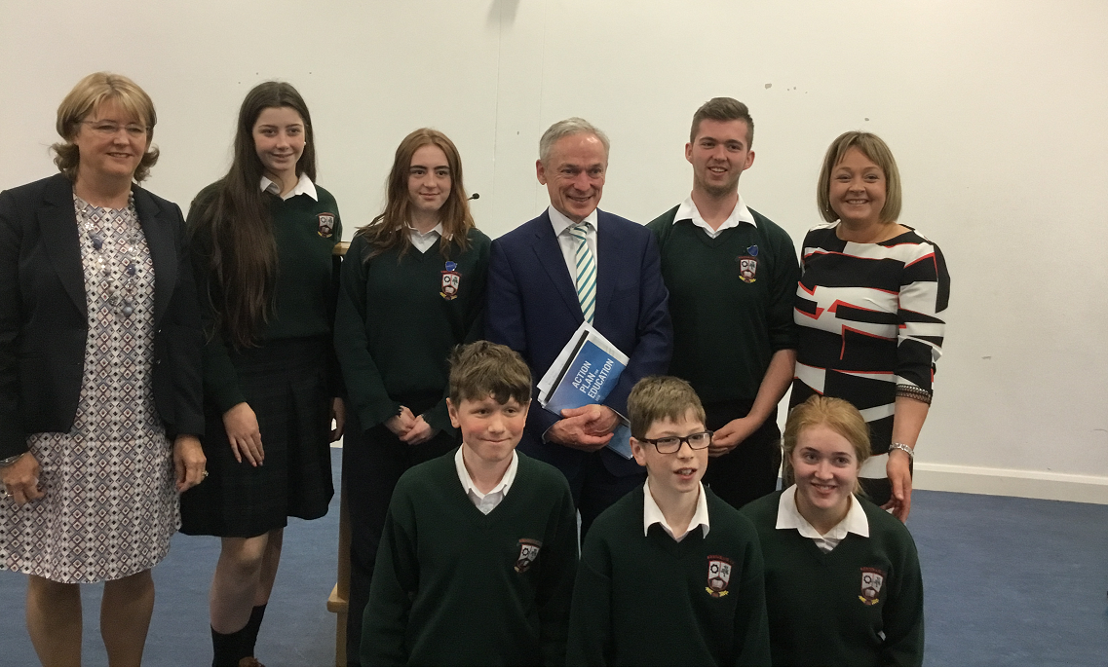

Borrisokane Community College represented at discussion meeting with Minister for Education. CE Tipperary ETB Ms Fionuala Mc Geever, Rachel Finn (TY), Katie Corboy (5th year), Minister Mr Richard Bruton, Michael Carroll (Head boy), Deputy Principal Suzanne McMahon,
Front: Jack Moyles (1st year) Dylan Dockery (2nd year), Ciara Cleary (TY).

Youth Group
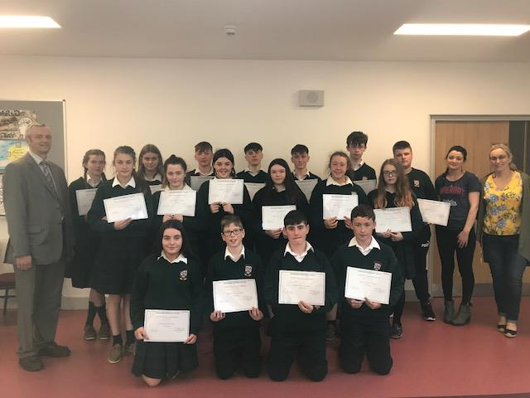
Matthew Carr Principal Borrisokane Community College with the students who successfully completed Youth group this year. A group of students that meet weekly and engage in activities to promote the key skill of working with others, communication and enhance their self-esteem. Ms Louise Ryan and Ms Áine Shanahan, co-ordinators of Youth group.

Homework Club
The Homework club had a very successful year, running every Wednesday 4 -5.30pm. As a reward for their hard work students were brought on an end of year trip to Athlone. They went to Jump Lanes and Bay sports with the 2nd year Youth Group where the students had a great time. The instructors commented on the excellent behaviour of the students and once again their respect and positive behaviour highlight positive promotion of the school. Well done to all involved.

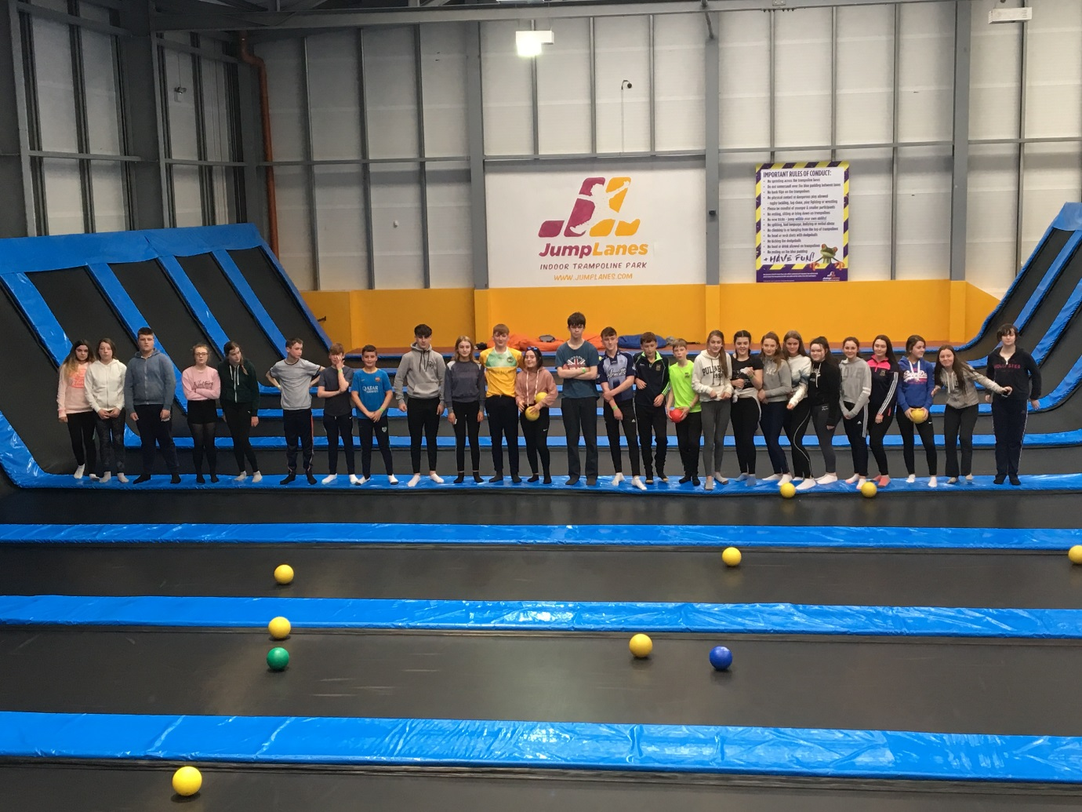
Borrisokane Community College students enjoy trip to Jump Lanes in Athone.

Student Council hope to bring the Kindness flag to BCC.
On Tuesday the 15th of May Borrisokane Student Council were invited to attend the presentation of Kindness Flags to schools in the Limerick area. The initiative was set up in 2016 to encourage random acts of kindness among students and thereby foster an atmosphere of positivity and wellbeing in the school. Students are asked to do something for another person without expecting a payback. Several educational establishments from pre-schools to LIT were presented with flags on the day. Pictured here are two representatives from our Student Council Ella Carey and Oisin Mc Mahon with students from Castletroy College after they were presented with their Flag. Borrisokane Student Council are working towards obtaining the Flag in the next school year.
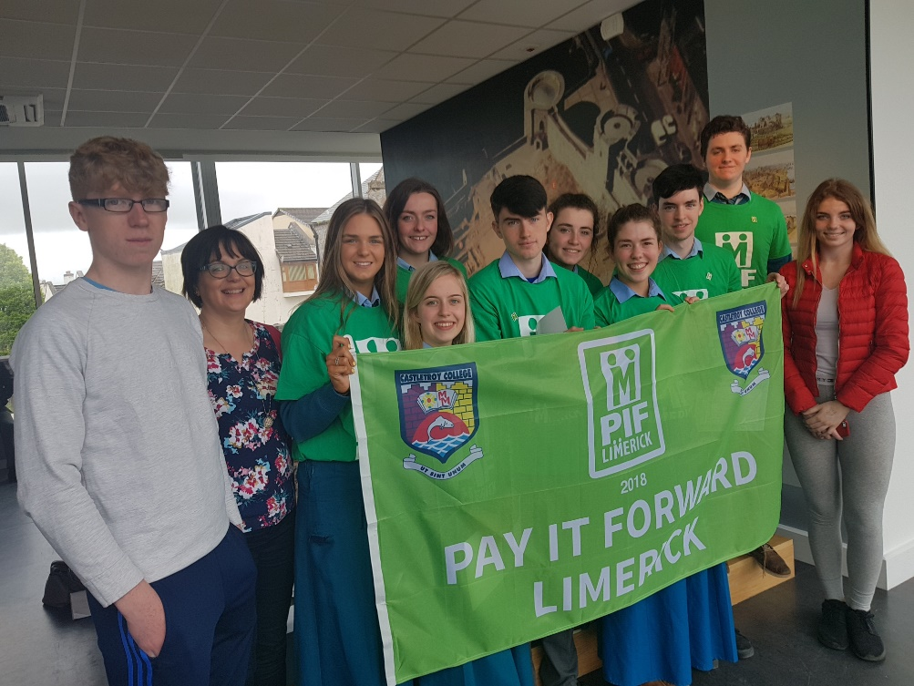
First year Camogie
1st year Camogie Girls trained under the guidance of Ms Eileen Lyons every Tuesday at lunchtime without hesitation no matter what weather conditions prevailed. They demonstrated an excellent attitude and commitment to training.
The team took part in numerous matches and blitz competitions throughout the year but were unfortunate not to bring home any silverware. They beat near neighbours Roscrea and Birr in challenge matches improving their skills with every game. On the 17th May they played a quarterfinal in the Munster blitz in Charleville narrowly losing out to a very strong Fermoy team. Ms Lyons was hugely proud of their great team spirit and the excellent behaviour and pride with which they represented their school. Special congratulations to Charlotte and Áine as they were also part of the victorious Junior Camogie team which won a Munster title.
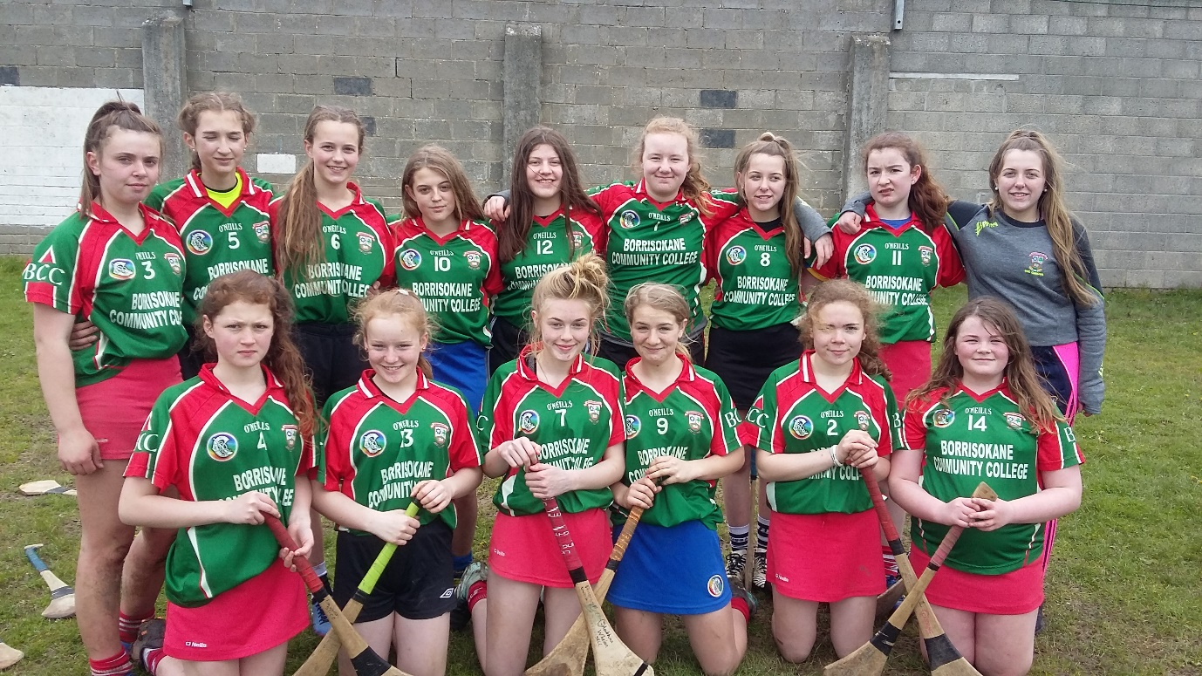
1st year girls camogie:
Back Row: Aine Leenane, Aisling Fox, Caoimhe Conroy, Chloe Culhane, Mieke Curran, Katelyn Landy, Kaci Sullivan, Tracey Burke, Leah Sullivan,
Front Row: Niamh Slevin, Leah D' Arcy, Ella Walsh, Charlotte Collier, Aoibhinn Whelan and Amy Sullivan. Absent from photo Chloe Morgan
Religion Trip
On 10th May the 2nd year students went to visit the Islamic centre and mosque in Limerick. There we listened to a talk given to us by the Imam at the mosque. We learned a lot about the religion and got the chance to ask questions. Everyone was very welcoming. When we arrived the girls covered their heads with a scarf as a sign of respect to the mosque. We also took off our shoes. We found it very important to show respect to other religions. After that we went for a walk in Kilcommon. We went to see the Parish church, a Celtic hut built from a 12th century Benedictine monastery and the holy water well. We learned that it was the purest holy well in Tipperary. We enjoyed being at one with nature instead of in a stuffy classroom. We really enjoyed the trip and learned lots about our topic of Religion.
2nd year student Gillian Craig.

Fundraising:
Borrisokane Community College Health Promoting schools organised another fundraiser to assist Seamus Hennessy in his Running For Josie campaign bid to raise €200,000 for Pieta House and Living Links Tipperary. Eight students organised a "Plait for Pieta" raising €160 for this worthy cause.

